Assignment 1
Introduction to Amazon Simple Storage Service (S3)
SPL-TF-100-STESS3 - Version 2.4.19
© 2026 Amazon Web Services, Inc. or its affiliates. All rights reserved. This work may not be reproduced or redistributed, in whole or in part, without prior written permission from Amazon Web Services, Inc. Commercial copying, lending, or selling is prohibited. All trademarks are the property of their owners.
Objectives
After completing this lab, you will know how to:
- Create a bucket in Amazon S3
- Add an object to a bucket
- Manage access permissions on an object and a bucket
- Create a bucket policy
- Use bucket versioning
Step 1: Go to the Amazon S3 dashboard and click on the orange "Create bucket" button to create a storage bucket.

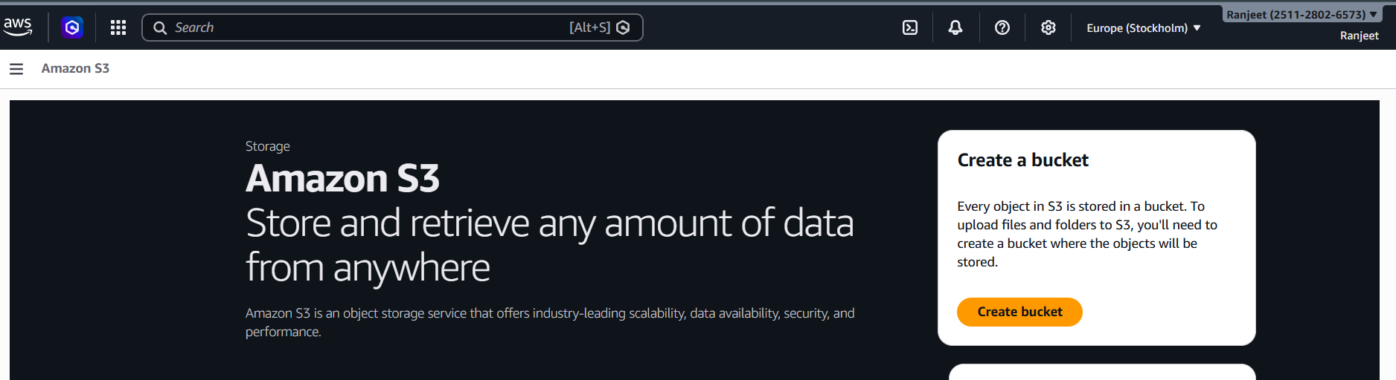

Step 2: Set the bucket name to "aws-s3-ranjeet" and select "Asia Pacific (Mumbai)" as the AWS Region.

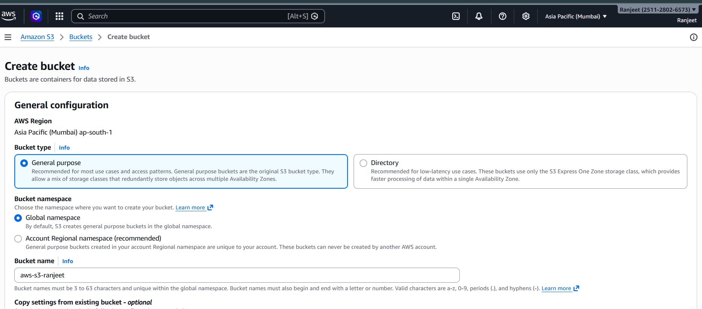

Step 3: In Object Ownership, choose "ACLs disabled" and keep the "Block all public access" option enabled for security.

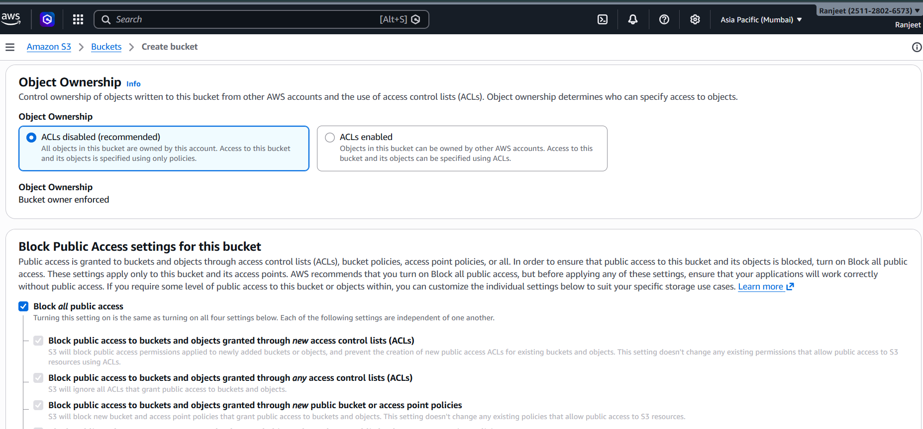
Step 4: Leave Bucket Versioning as "Disabled" and keep the option to add tags at its default setting.

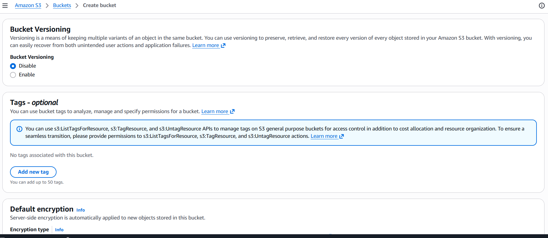

Step 5: In Encryption, select "SSE-S3" (managed keys) and click on "Create bucket" to create the final bucket.

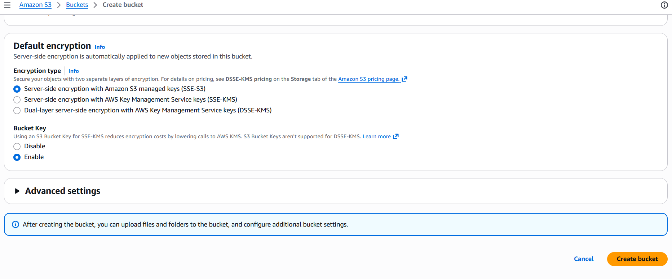

Step 6: After the bucket was successfully created, click on the "Upload" button to add files inside it.

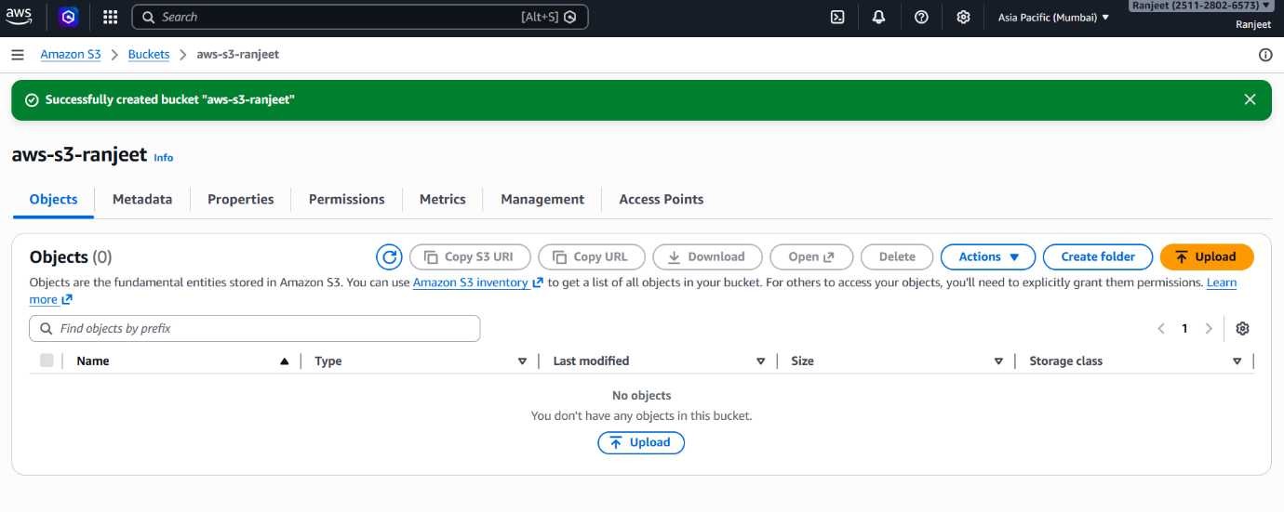
Step 7: Click on "Add files" and select the image file named "a 3D depiction of Lo.png" from your local system.

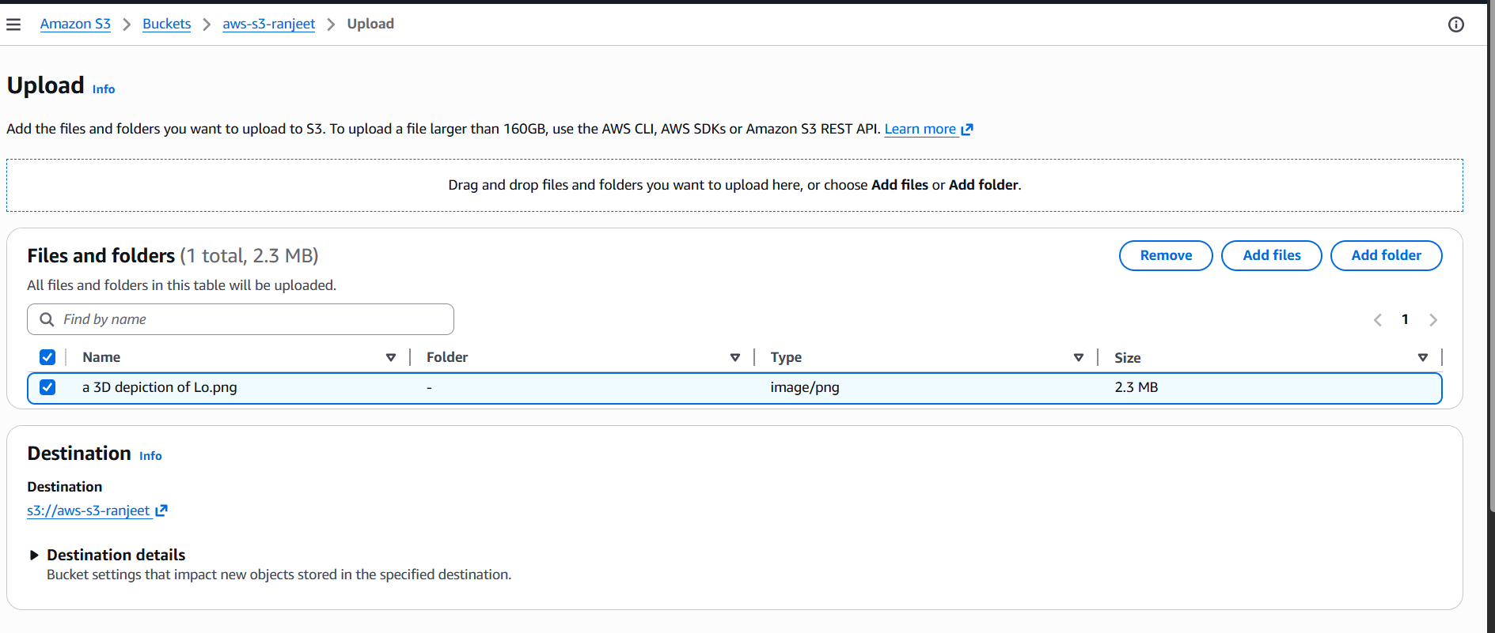

Step 8: After the upload process is complete, check the "Upload succeeded" status, which confirms that the 2.3 MB file has been successfully uploaded.

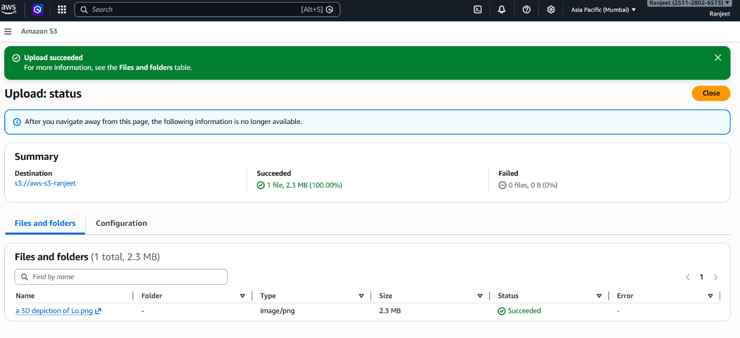
Step 9: Click on the uploaded file to check its Properties, where the file’s S3 URI, ARN, and Object URL are generated.

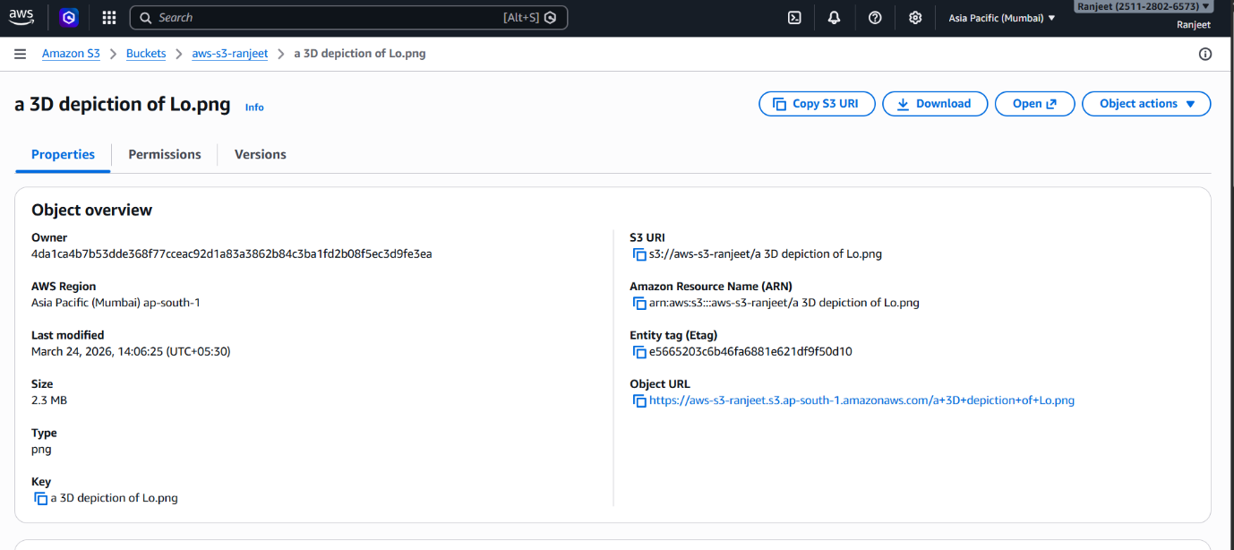
Step 10: File Upload
Shows the successful upload of the core website file.
- Action: The file index.html (1.6 KB) was uploaded to the S3 bucket named ranjeet-website-01.
- Result: AWS confirmed "Upload succeeded," placing the content into the storage bucket.

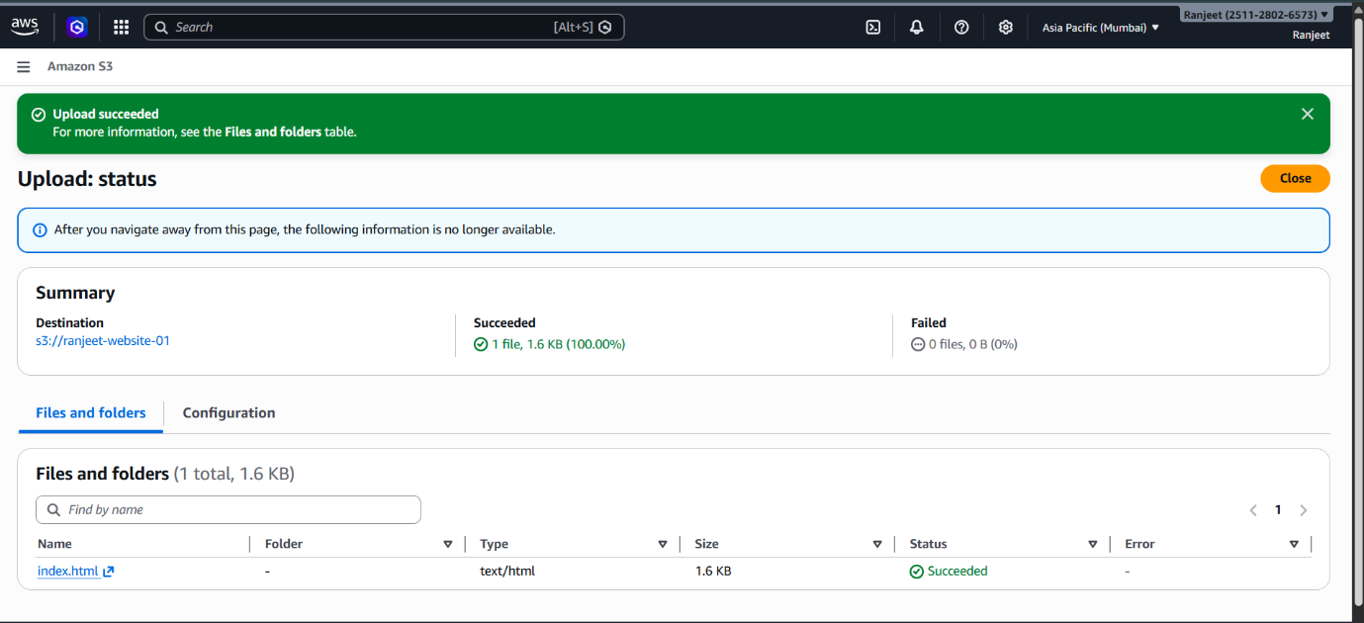

Step 11: Accessing Bucket Properties
Shows the Bucket Overview and configuration area.
- Action: Navigation to the Properties tab of the bucket.
- Details: The bucket is located in the Asia Pacific (Mumbai) ap-south-1 region. This is where settings like Versioning (currently disabled) are managed.

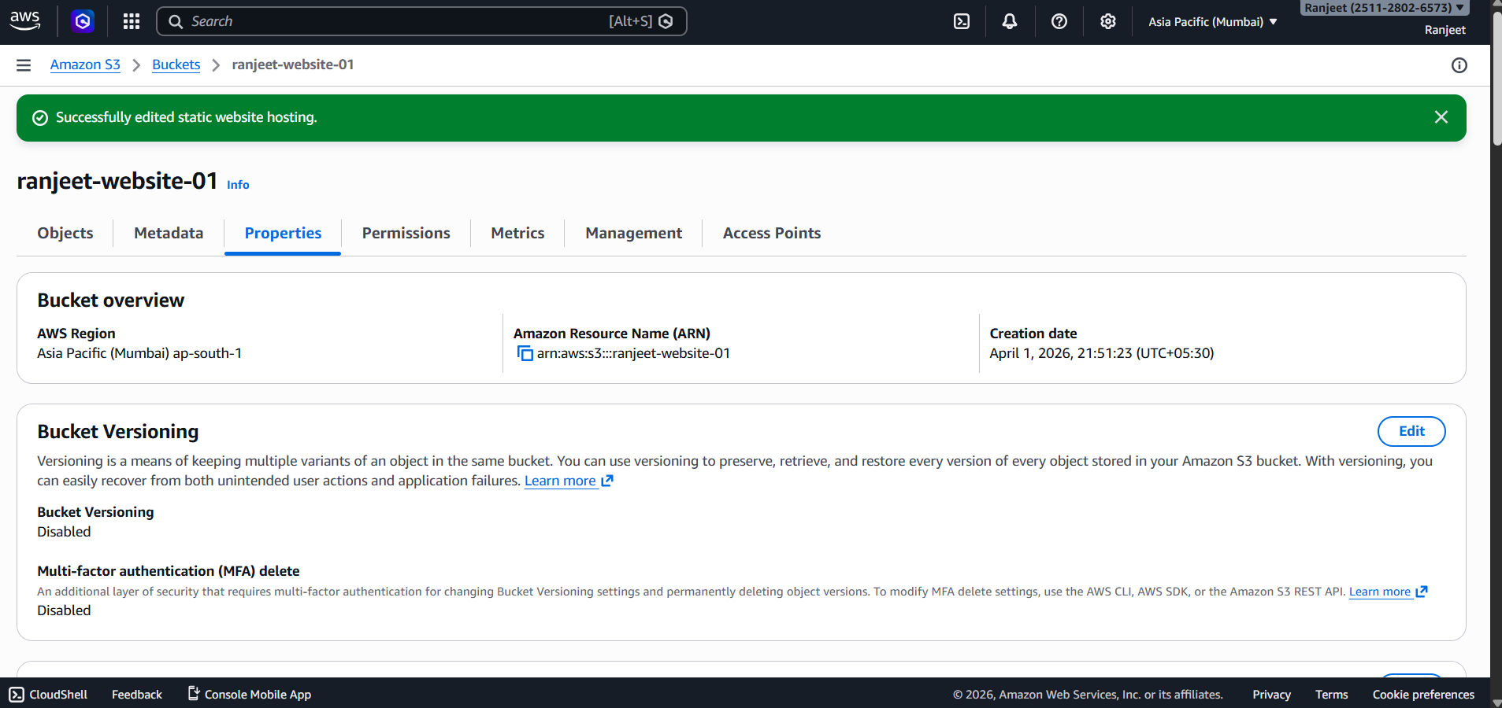

Step 12: Enabling Static Website Hosting
Shows the activation of the hosting feature.
- Action: The Static website hosting setting was set to Enabled.
- Result: AWS generated a unique Bucket website endpoint: http://ranjeet-website-01.s3-website.ap-south-1.amazonaws.com.

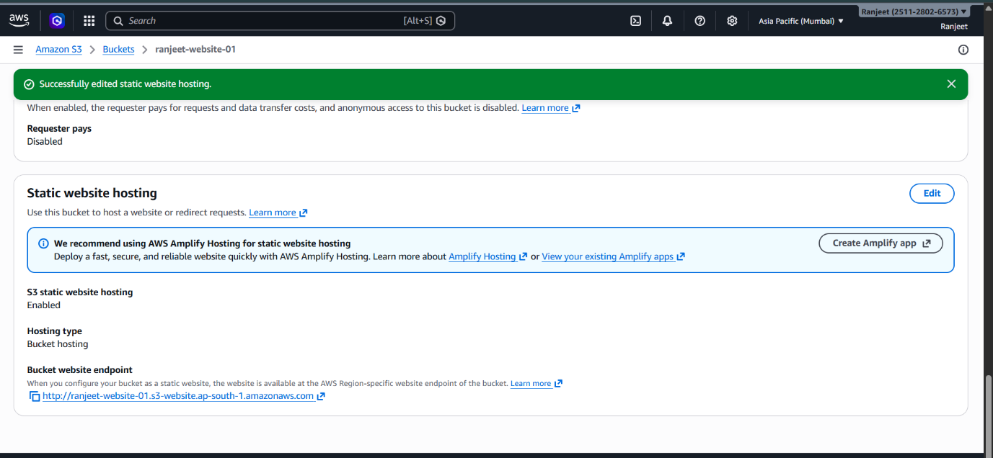

Step 13: Configuring the Bucket Policy
Involve setting up Permissions via a JSON policy.
- Action: A public-read policy was applied to allow the internet to view the files.
- Technical Detail: The policy uses the s3:GetObject action with the Principal: "*" to grant access to anyone with the link.
- Security: "Block all public access" was turned Off to allow this specific public use case.

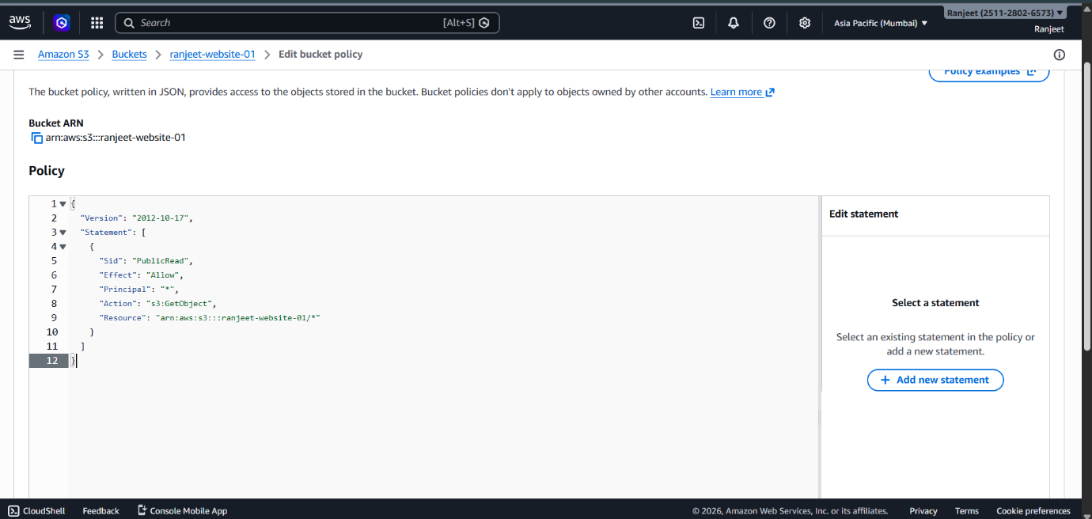

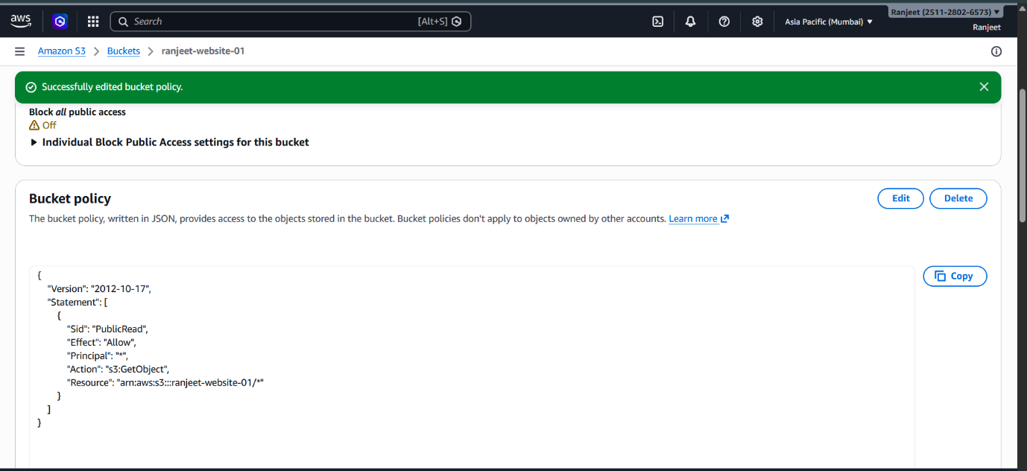
Step 14: Live Website Verification
Shows the Result of the previous steps.
- Action: The generated S3 endpoint was opened in a web browser.
- Outcome: The "Ranjeet Kumar Portfolio" website is successfully live and accessible, displaying the "Hello, I'm Ranjeet" landing page.

